WE WANT YOU!

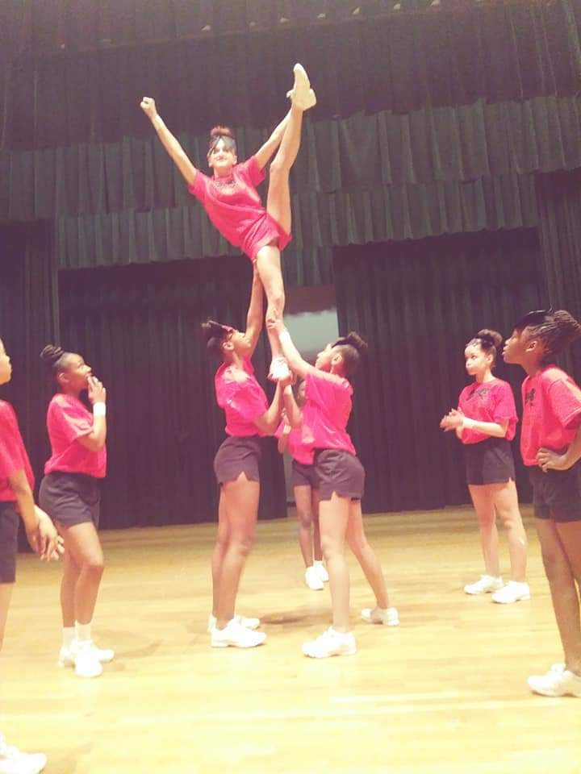

Are you interested in joining the PHENOMENAL Rockets Cheerleading Squad? Well, come out for our preseason conditioning. This is the perfect place to start your journey as an AGMS Rocket “Bomb Squad” Leader. Conditioning will take place from 3:00 p.m. – 5:00 p.m., on August 19, 21, 23, 26 and 28. **YOU MUST HAVE AN ATHLETIC SPORTS PHYSICAL TO PARTICIPATE.** Please dress in comfortable clothing that is suitable for being both outdoors, as well as indoors. You will also need to bring a water bottle, 1 small towel, sunblock, a bag (to keep items in), and any needed medical or hygiene products.

Parents, conditioning is closed to non-participants. Please wait for your son(s), or daughter(s), in the main parking lot on the side of the school building. Please ensure that your student has a ride waiting promptly at the conclusion of each day of conditioning. In the event of inclement weather, or extreme heat, conditioning will be held inside of the gymnasium, unless the weather is bad enough for NPS to cancel ALL athletic practices.

Attending conditioning does not guarantee a student will make the cheerleading team. Football Sideline Tryouts will take place September 3rd, 4th and 5th. Tryouts are held in a “Clinic” style. You must attend ALL three days of tryouts to receive a **complete** tryout score. Tryouts will take place from 3:00 p.m. - 4:45 p.m. All participants must arrive on time, and exit the building by 5:00 p.m. Attendance is a part of your tryout score. You MUST present your Athletic Sports Physical Form at the start of Tryouts (if you did not participate in “Conditioning”) in order to participate. NO EXCEPTIONS! If you do not have a sports physical form, you must go home during the regular dismissal time.

If you have any questions please feel free to contact me using the following:

Coach Thomas

[kthomas@nps.k12.va.us](mailto:kthomas@nps.k12.va.us)

Main Office: (757) 531-3000

**ATHLETIC PHYSICAL CLINICS**

|  |  |  |
| --- | --- | --- |
| **Location:** | **Date:** | **Time:** |
| Granby High School | 8/01/2019 | 5:00 p.m. |
| Lake Taylor High School | 8/05/2019 | 5:00 p.m. |
| Norview High School | 8/14/2019 | 5:00 p.m. |
| Booker T. Washington High School | 8/21/2019 | 5:00 p.m. |
| Ruffner Academy Middle School | 8/26/2019 | 5:00 p.m. |
| Norview Middle School | 8/28/2019 | 5:00 p.m. |

On behalf of the NPS Office of Athletics, we encourage all student athletes to visit their primary care physician for a comprehensive physical before competing in athletics. We do offer onsite physicals at the above listed locations throughout the year for individuals who cannot obtain a comprehensive physical. The cost is **$20.00** cash only. Please access the physical form, or pick one up from your middle school, and fill out parts I, II, and IV prior to attending an onsite physical at one of our schools. If any of those three parts are incomplete before attending an onsite physical, the student athlete **will not** be given a physical on that day. **All completed physicals must be dated after May 1st, 2019.**

**\*\*\*You may attend any Athletic Sports Physical Clinic regardless of school, or grade level\*\*\***